TRAINING PLAN FILLING GUIDE

Section 1 – Participant Information
This section includes the participant’s personal and academic/professional information. Please make sure the participant’s name matches their passport exactly and that the program dates, degree information, and occupational field are accurate. This section may also be completed later by the agency or Sponsor; however, it is important that the information is reviewed carefully for accuracy and consistency.

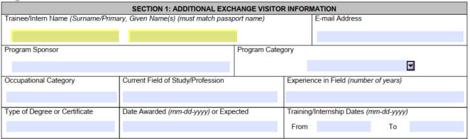

Section 2 – Host Organization Information
This section includes the company’s official information and is one of the areas most carefully reviewed by sponsors. Please ensure all details are accurate and complete, especially:
- Number of full-time employees onsite
- Workers’ Compensation policy information
- Annual revenue
- Compensation and working hours
- Host company address and supervisor details
Sponsors usually verify that the host company has the structure, staffing, and resources necessary to provide a proper training environment for the participant.

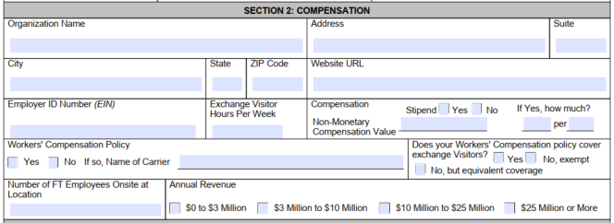

Section 4 – Training/Internship Placement Plan
This is the most important section of the Training Plan. Each phase contains specific questions designed to describe:
- The participant’s role
- Training objectives
- Skills and knowledge to be learned
- How the training will be conducted
- How progress will be evaluated
Training phases should demonstrate progression throughout the program, meaning responsibilities and learning opportunities should become more advanced over time.
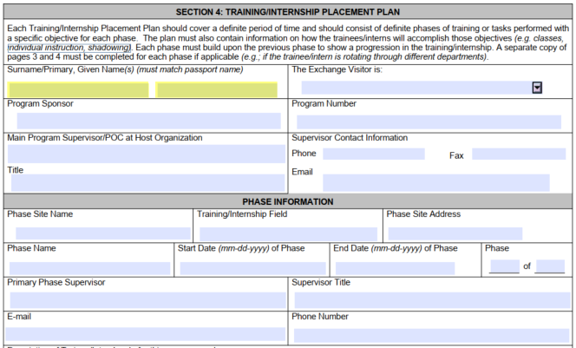
Please avoid very general descriptions such as “assist staff” or “daily operations.” Instead, provide detailed and training-focused explanations that reflect structured learning and professional development.
The training plan should focus on mentorship, learning experiences, and skill development rather than regular employment or repetitive operational work.
Typically, Training Plans are divided into 4 phases. Phase 1 is always an Orientation phase, where the participant becomes familiar with the company culture, policies, procedures, safety standards, and basic operational structure before moving into more advanced training responsibilities in the following phases.

Main Point Of Contact & Supervisors per phase
Sponsors pay close attention to the supervisor and main point of contact information. Please make sure all fields are completed accurately, including:
- Name
- Job title
- Phone number
- Email address
- Professional qualifications
The qualifications section should explain why the supervisor is qualified to train and mentor the participant. This may include:
- Years of experience in the industry
- Years working with the company
- Management or leadership experience
- Specialized knowledge or certifications related to the training field
Example:
“John Smith has over 8 years of experience in hospitality management and has worked as Front Office Manager at the company for the past 5 years, supervising and training new staff members.”
Please make sure each section is answered with detailed and training-focused information to clearly demonstrate the participant’s learning experience throughout the program.

Cultural Activities
The program must also include cultural exchange opportunities. Please describe activities that will help the participant experience American culture inside or outside the workplace, such as local events, holidays, community activities, team outings, or sightseeing opportunities.
It is not necessary to organize activities on a monthly or quarterly basis. However, the Training Plan should include cultural exchange opportunities throughout the program to demonstrate that the participant will have exposure to American culture as part of their experience in the United States.

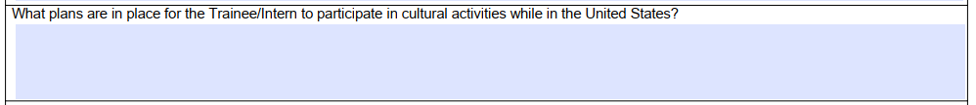

Final Review
Before submitting the Training Plan, please double-check:
- Dates and phase timelines (Agency can help with this)
- Supervisor information (Name, title, phone number, email and qualifications)
- Consistency between duties, objectives, and the participant’s background
A detailed and well-structured Training Plan helps avoid revisions and speeds up the sponsor review process.

